**Work environment setup on Ubuntu VirtualBox**

1. **How to Install Terraform in Ubuntu**

curl -fsSL https://apt.releases.hashicorp.com/gpg | sudo apt-key add –

sudo apt install curl

sudo apt-add-repository "deb [arch=$(dpkg --print-architecture)] https://apt.releases.hashicorp.com $(lsb_release -cs) main"

sudo apt-get update && sudo apt-get install terraform

terraform –version

1. **How to Install git in Ubuntu**

sudo apt update

sudo apt install git

1. **How to Install mc (Midnight commander) in Ubuntu:**

* **Midnight Commander - a powerful file manager**
* GNU Midnight Commander is a **text-mode full-screen file manager.**
* It uses a two-panel interface and a subshell for command execution.
* It includes an internal editor with syntax highlighting and an internal viewer with support for binary files.
* Also included is Virtual Filesystem (VFS), that allows files on remote systems (e.g. FTP, SSH servers) and files inside archives to be manipulated like real files.

sudo apt update

sudo apt install mc

1. **How to Install curl & Wget in Ubuntu**

sudo apt install curl

sudo apt install wget

1. **How to Install AWSCLI in Ubuntu**

ssudo apt install update

sudo apt install aws

1. **Adding ssh key in virtualbox**

sudo apt update && Upgrade

ssh-keygen

cd .ssh

ls -lart

1. **How to Install VirtualBox Guest Additions in Ubuntu**

**Method-1:**

sudo apt update && apt upgrade

reboot

sudo apt install build-essential dkms linux-headers-$(uname -r)

sudo apt-get install virtualbox-ose-guest-x11

**Method-2:**

Cd /opt

sudo apt-get install virtualbox-guest-additions-iso

The .iso file with an image of the OSE edition of the guest additions CD will install in the host **directory /usr/share/virtualbox/VBoxGuestAdditions.iso**

sudo apt install build-essential dkms

**GNOME Shell**

To install the Guest Additions we will have a CD icon on our desktop as soon as the virtual drive is mounted:

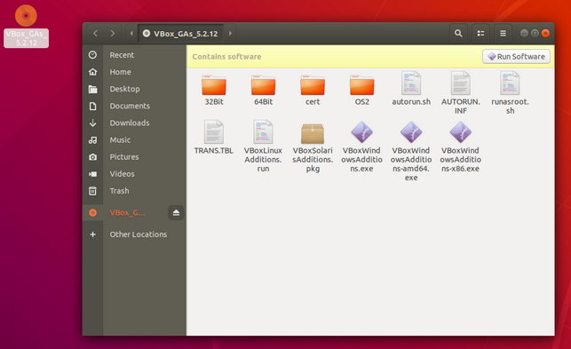

enter image description here Next step is to run the **autorun.sh script** **(as root)** on this mounted CD by opening the drive and clicking on the "Run Software" button.

**Installing Guest Additions from a Terminal:**

mount /dev/cdrom /mnt # or any other mountpoint

cd /mnt

./VBoxLinuxAdditions.run

Reboot

**Remove Guest Additions:**

cd /opt/<VirtualBoxAdditions-x.x.xx>/

sudo ./uninstall.sh

**Reference:** <https://askubuntu.com/questions/22743/how-do-i-install-guest-additions-in-a-virtualbox-vm>

**How to setup MFA for AWS Account:**

**Step1:**

To enable MFA on your AWS root account we must first browse to a service called **IAM (Identity and Access Management).** You can do this by typing in IAM in the search services field.

**Note:** The IAM service is Global and is not tied to a specific region and user should have AWS console Access.

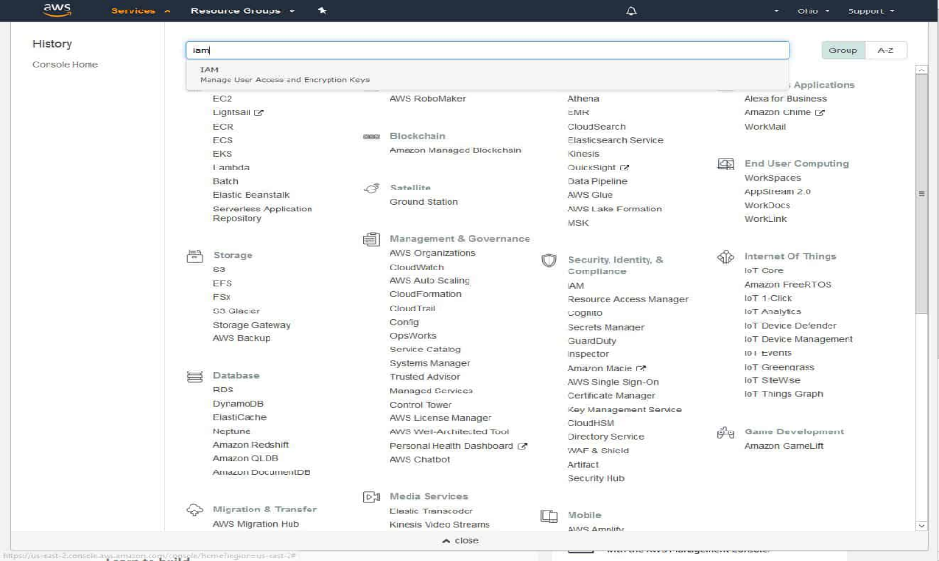

* When you are in the IAM service you will want to click on **user**
* Click on ‘**Security Credentials’**
* “**Assigned MFA device”** under Security Status. Click on **manage**
* Make sure ‘Virtual MFA’ device is selected and click on Continue.

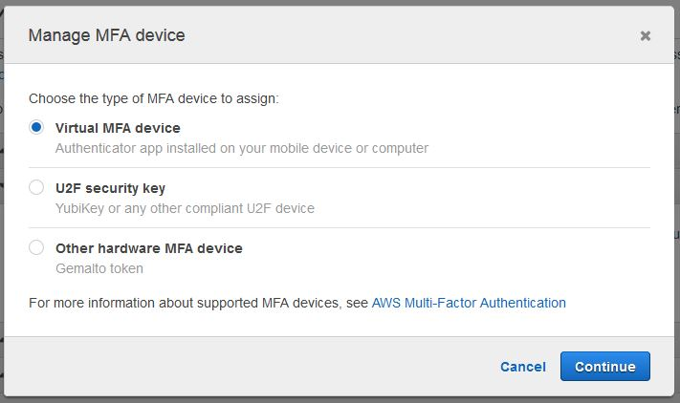

**Step-2:**

* In this demonstration, we are going to use **work Google Authenticator** to provide one-time passwords.
* Launch **Google Authenticator** from **your phone** and within the app click on the **+ symbol** at the top right-hand side to add a Add account (**Work or School Account).** Select Scan **barcode.**
* Enter 2 consecutive codes into **‘MFA code 1’ and ‘MFA code 2’** fields and click on **Assign MFA.**
* Your Multifactor authentication on your root **AWS account** is now complete and ready to use.